
Business Question and Visualization Report

Date | 26 October 2026
Team ID | Individual
Project Name | Electric Vehicle Market Analysis Dashboard
Maximum Marks | 5 Marks

Visualization development refers to the process of creating graphical representations of data to facilitate understanding, analysis, and decision-making. The goal is to transform complex datasets into visual formats that are easy to interpret, enabling users to gain insights and make informed decisions. Visualization development involves selecting appropriate visual elements, designing layouts, and using interactive features to enhance the user experience. This process is commonly associated with data visualization tools and platforms, and it plays a crucial role in business intelligence, analytics, and reporting
Business Questions and Visualisation
The process involves defining specific business questions to guide the creation of meaningful and actionable visualizations in Tableau. Well-framed questions help in identifying key metrics, selecting relevant data, and building visualisation that provide insights.
1. Which vehicle categories drive the most annual sales volume, and how does this compare with revenue contribution?
  - Visualization: Dual-axis dot plot of Annual Sales Units and revenue by vehicle category.
  - Insight: Two-Wheeler Scooter shows the highest labelled volume at about 174.6M units, while several other categories sit between roughly 95M and 155M units.
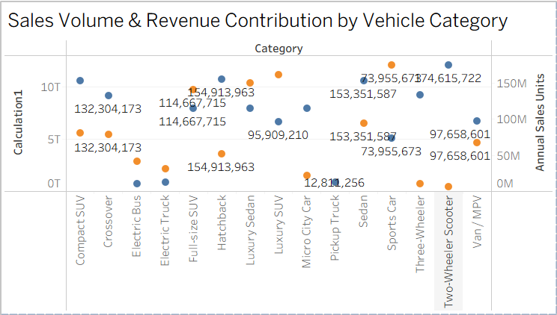
2. How is annual sales volume distributed across manufacturers and across each manufacturer's portfolio?
  - Visualization: Stacked horizontal bar chart of Annual Sales Units by manufacturer, split by colour-coded segments.
  - Insight: Every manufacturer reaches into the multi-million unit range (axis up to 8M), and the red segment forms the largest share in most bars.
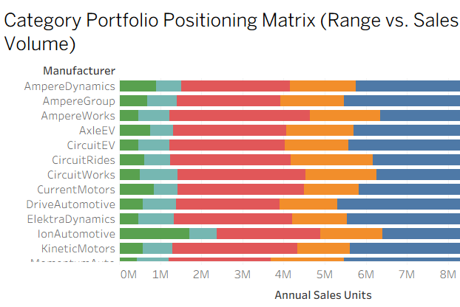
3. Which battery technology carries the most weight in the range vs price efficiency benchmark?
  - Visualization: Treemap of battery types (NMC, NCA, LFP, Sodium-Ion) sized and shaded by the benchmark measure.
  - Insight: NMC and NCA occupy the largest tiles, with LFP and Sodium-Ion below them.
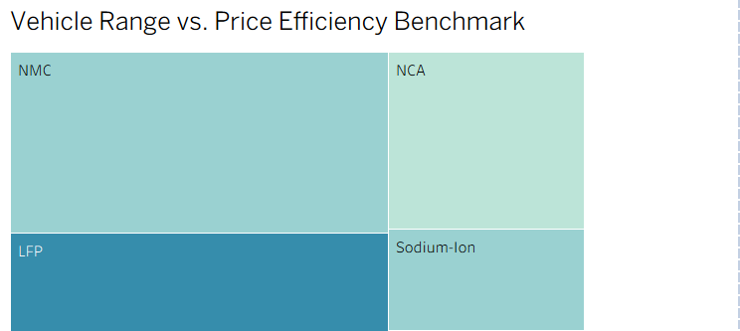
4. How does each manufacturer's annual sales compare with the market average?
  - Visualization: Scatter plot of manufacturers with an average reference line (Manufacturer Market Share Leaderboard).
  - Insight: A few manufacturers stand out at about 4.79M and 4.73M units, while most cluster around or below the average line.
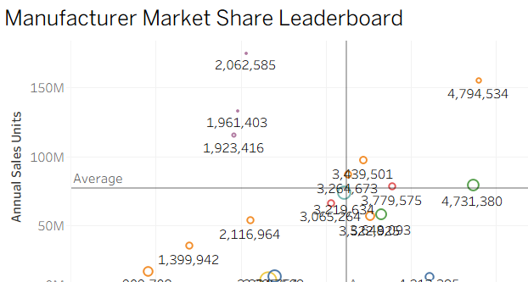
5. Where are the main production hubs and export origins located?
  - Visualization: Map visualization with symbols marking production hubs worldwide.
  - Insight: Hubs cluster in Western Europe and the Nordics, with additional hubs in North America and South and East Asia.
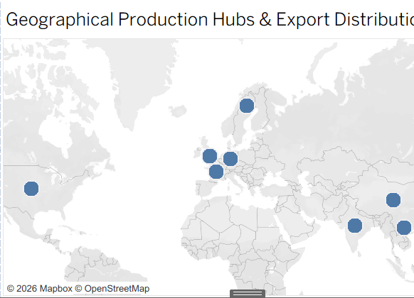
6. Which vehicle categories deliver the longest average driving range?
  - Visualization: Horizontal bar chart of Avg. Range Km by vehicle category.
  - Insight: Crossover (about 1,180 km) and Compact SUV (about 1,100 km) lead the visible categories, followed by Electric Bus at about 810 km.
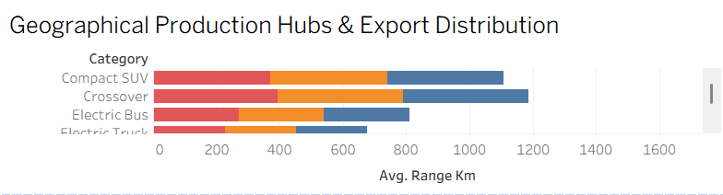
7. How are battery types distributed across vehicle categories?
  - Visualization: Heatmap of vehicle category against battery type (LFP, NCA, NMC, Sodium-Ion, Solid-State).
  - Insight: LFP and NMC columns are the darkest across most categories, while Sodium-Ion and Solid-State are the lightest.
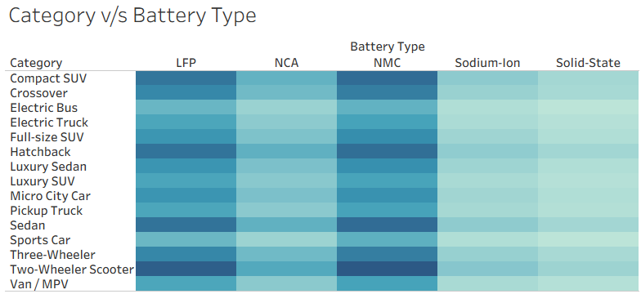
8. How do range and customer rating vary across battery technologies?
  - Visualization: Scatter plot of Avg. Range Km against Avg. Customer Rating, coloured by battery technology.
  - Insight: Battery technologies form distinct clusters from about 100 to 550 km of range, but ratings stay within a narrow 3.8 to 4.4 band.
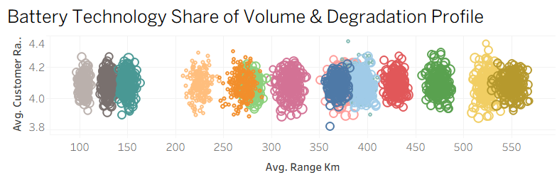
9. What share of total annual sales units does each segment contribute?
  - Visualization: Pie chart of Annual Sales Units (CSAT & Environmental Impact Matrix).
  - Insight: Total volume is about 1.55B units; the two largest slices (about 524.1M and 496.1M) make up roughly 65.8% of it.
